HM5001 Transformer Turns Ratio Tester
User MANUAL
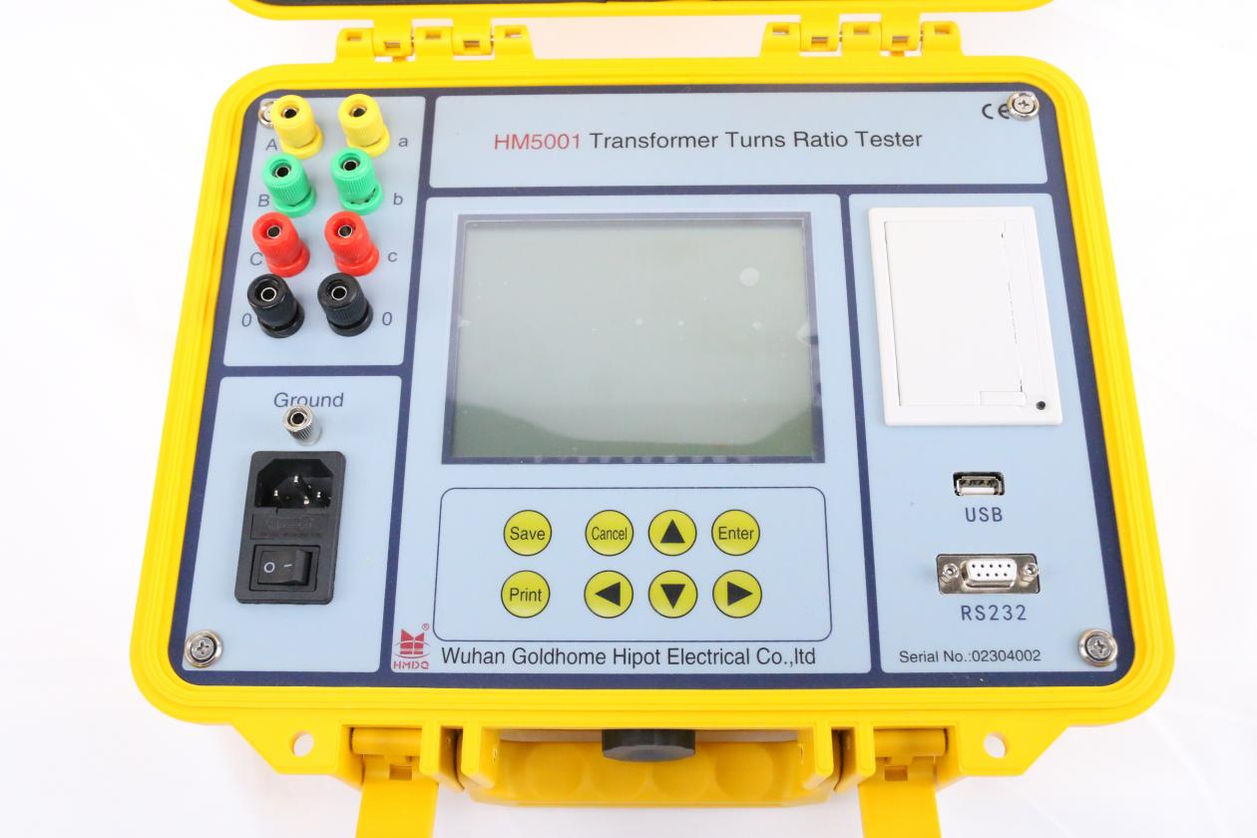
WUHAN GOLDHOME HIPOT ELECTRICAL CO.,TLD
Tel.：+86-13720265142 Fax：+86-27-84625205
Email:goldhome03@cablehipot.com Web.: www.hvcablehipot.com
Add.: No.A25-1, Huading Mould Industrial Park, Hannan, Wuhan, Hubei, China

CONTENTS
1 Product overview ...................................................1
2 Function Characteristics.........................................1
3 Technical Parameters..............................................1
4 Service Condition...................................................1
5 Panel Instruction.....................................................2
6 Key Introductions...................................................3
7 Operating instructions..........................................3
8 Note items..............................................................12
9 .Fault analysis.........................................................13
10.After-sale service..............................................13

Product overview
In process production of the power transformer’s semi-finished products and finished products ,before the newly installed transformer put into operation, according to the preventive test code of the state power department, it is required to run regular transformer turns ration or voltage ratio test.

Function Characteristics
- Test wide range, the highest ratio can be measured up to 10000;
- The built-in three-phase digital power supply, to improve the stability of the test.
- Small volume, light weight, fast test speed,10 seconds to complete the test phase.
- Z shaped linking transformer testing
- have blind test ratio, group test function.
- The display of clock and date on not power down, the function of data storage(can select to save data to the U disk)
- the function of high and low voltage reverser polarity protection, short circuit protection.
- the function of thermal printer output, fast speed, low noise.
- Full penetration type large-screen LCD, can clearly show in the sun.

Technical Parameters
- range of measurement 0.9~10000
- resolution minimum 0.0001
- Accuracy 0.2level
- Output Voltage 120 V
- Dimension 345mm×295mm×175mm
- Instrument weight 5Kg

Service Condition
- Environment temperature -10℃～50℃
- Environment humidity ≤85%RH
- Working power AC127V
- Supply frequency: 60Hz

Panel Instruction
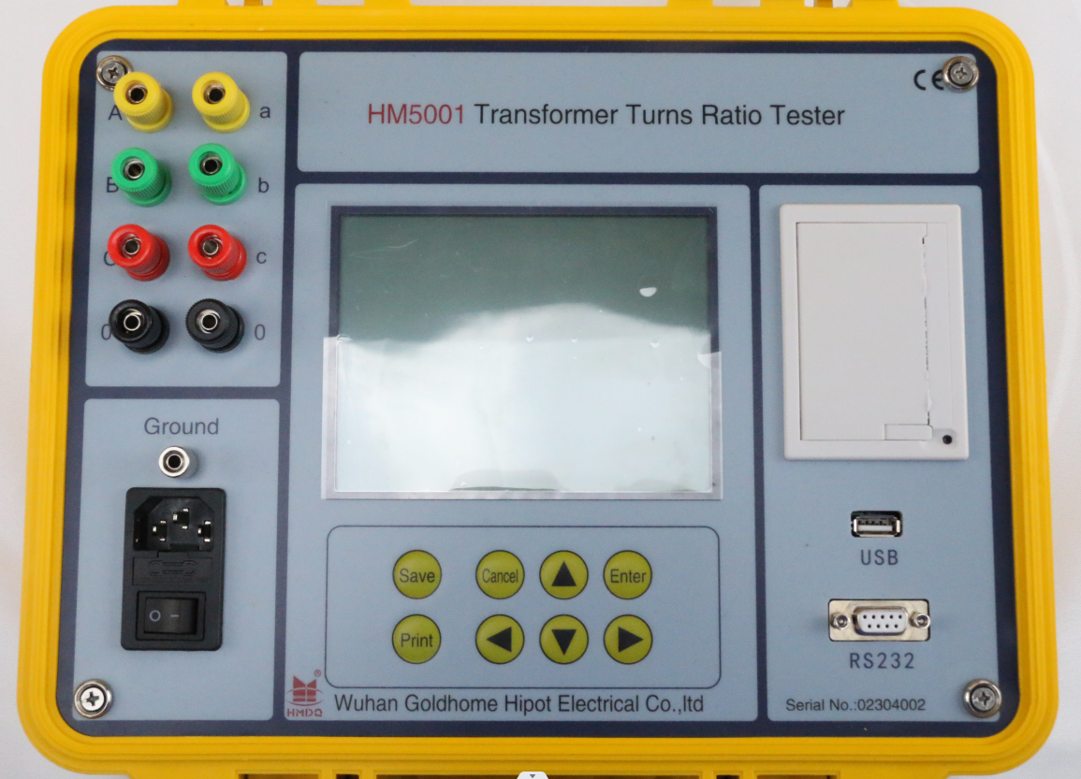

1. High-Voltage A ,B ,C three-phase of the measured transformer
2. Low-Voltage a,b.c three-phase of the measured transformer
3. Switch To turn on or turn off the power supply test device
4. Earthing rod Before any testing ,please contact the earthing rod to the ground ,so as to avoid electric shock hazard.
5. Printer print the test data.
6. LCD panel Display, Black character on white background, can be clearly display in the sun.
7.Key disk Used for operating equipment。
8.U S B Connect USB flash disk, save data。
9.RS232 Used for upgrade programs。

Key Introductions
Save
OK
Back
Print
SEL
- OK Confirmation of the selected project.
- Back return the last layer on the menu
- Save save data, the test data is stored to the apparatus main memory or the external U disk
- Print print the test result data
- ↑↓ select to move up or down, and the data to edit add or sub 1
- ←→ select to move left or right ,and the data bits to edit move left or right
- SEL different panel have different function

Operating instructions

Instrument wiring
- Single-phase ratio wiring（the unused test line hung up is ok ）, as shown in the figure。
X 0
Transformer
X 0
High voltage test
yellow

green
yellow

green

Low voltage test
- Three-phase ratio connection as shown:
A B C
Transformer
a b c
yellow green red
red green yellow
Low voltage test wire

High voltage test wire

Starting Interface
After as required to connect the test line, open the power switch of the panel, the starting interface will display as shown
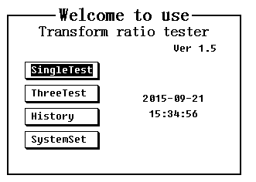
On this interface ,press the key ↑ ↓,select the various function of the instrument, each function instructions as follow,
- SingleTest the ratio of single-phase transformer and voltage transformer
- ThreeTest test the ratio of Three –phase (include Z shape) transformer
- History view the stored historical data
- SystemSet setup the system parameters such as setup time

Parameter setting interface
Parameter setting interface is used to set transformer parameters of using in ratio test, and test the sequence number of sample
The two pictures of parameters setting interface as shown, First one shown interface is transformer connection mode and group number set, It is appear only in three-phase measurement ,single-phase measurement do not need to setup. Second picture shown interface is the related parameters setting of transformer rated ratio and tapping switch
After you press “save” key ,the setting up parameters can be saved to the instrument internal flash memory, as the default parameter values for each boot.
If system setting interface have selected“Automatic Identifying”，it will automatic identify the group number only the group number setup as “XX”.

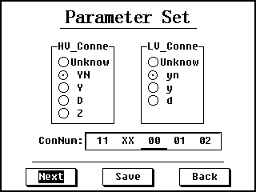

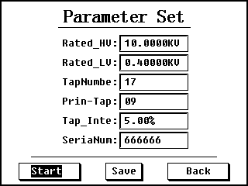
Parameter instruction
- Rated_HV: setting the rated high voltage of the measured transformer (setting as the transformer nameplate )
- Rated_LV：setting the rated low voltage of the measured transformer(setting as the transformer nameplate )
- TapNumbe: setting the total number tapping of the measured transformer(setting as the transformer nameplate) if setup as 0,the instrument will not judge the location of tapping
- Prin-Tap: setting the tapping location of the measured transformer’s rated tapping. When setting the total number of tapping, it will default to change to intermediate tapping ,if rated tapping is not intermediate tap, it can be changed manual.
- Tap_Inte: setting the tapping space of the measured transformer(setting as the transformer nameplate )
- SeriaNum: Users can set the test number used for record each test random.

Single-phase ratio test results interface
After the single-phase test，the interface turn into single-phase test result interface as follow shown：
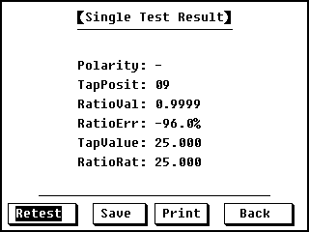
the picture shown the all test result in the interface，the setting parameters not shown in the interface but it is included in the printer result. If select “Retest”，it will test use the new setting parameters.
If you press “select”the interface turns into “parameter setting”, it is different from starting into “parameters setting“ interface，this parameters setting will directly re-calculation ”ratioVal“,”TapPosition“，“TapValue”“RatioErr“and other parameters on the measured data。After test, if find ratio error or tapping position is wrong, press ”select“ turn into ”parameter setting“interface review and correction the parameters .
Press the “Back“key can quickly return to the previous screen, press the ”Save“ key can quickly save the results to the fuselage memory or U disk, press the “Prin” key you can quickly print results.

Three-phase ratio test results interface
After the completion of the three-phase test, it turn into the three-phase test results interface as shown, the same with single-phase test results displayed on this screen, it only displays all test results without displaying parameter settings, the results printed out will include parameter settings . press “Retest“，it will re-measure with the setup parameter.
The same with the single-phase test results interface, in this interface press “SEL“ button can also turn into the ”parameter setting “ interface, but the group number only work in next measurement ,it can not play a role for the measured data.
Press the “Back“key can quickly return to the previous screen, press the”Save” key can quickly save the results to the fuselage memory or U disk, press the ”Print“ button you can quickly print results.
Three-phase testing process is to add the angle of the three-phase power measurements to calculate the group number, then according group number conduct the measurement variable ratio. But it will directly conduct ratio test if choose stand-by power , group numbers should be input in strict accordance with the transformer nameplate.

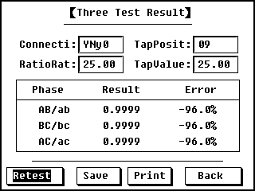
Three-phase ratio test results interface
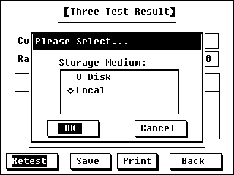
press “save” key popup storage medium selection interface

History record interface
History record interface is used to manage data stored in the body memory.
As it is shown below, users can find the experimental record by the test number and the recording time.
In the following interface, Press the key “Save” to store the data into U disk and press the key “SEL” to delete the test records.

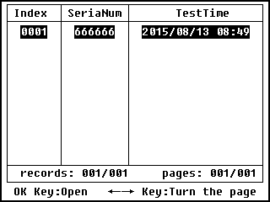
The following figure shows the test record that displays the details of history.

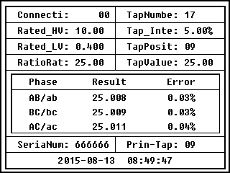
In the interface, press the key “Save” to store the data into U disk and press the key “print” to print the test records. Print the key ←→ to change the displayed records. Print the key “Back” to go back to the previous interface.
Press the key “SEL” in the history records interface to turn into the data management interface as follows. Select “DeleteCur” and then press the key “OK” to delete the currently selected records. Select “DeleteAll”and the key “OK” to delete all the history records. Select “Back” and then the key “OK” to return the history record interface without any processing.
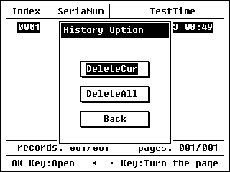

System setting interface
In the main menu, select "SystemSet" to open the system setting interface as shown.
In the following picture, "Calibrat" and "OtherSet" are used by the manufacturer for the testing of the instrument. Users need not use password protection. "TimeSet" can open the time setting interface and users can set the time.
If you select "Use 10V Power" option, you will test by a power of 10V. If the current is too large and you are sure it is not caused by a short-circuit, this option should be selected to test.
If the "Automatically Identifying " option is selected, the group number set by users will not work and the tester will automatically identifying the group number for each measurement.
If the "Emergency power" option is selected, the standby power inside the instrument is used to test. This option is available only when the main power fails to work and the standby power can not recognize the group number.
If there are changes to the parameters when they are returned, the parameters are automatically saved.
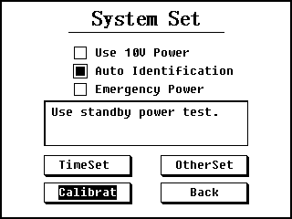

If the "Time Setting" option is selected, the time setting interface is shown as follows. Press the key “OK”to make the system time change as you set, and the tester will go back to the starting interface. Press the key “Back” to abandon modifying time and return to the initial interface directly.

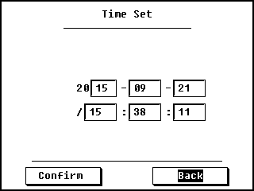

Note items
- Do not put the tester on an unstable platform or desk to prevent it from drop impact.
- The power used by AC 220V, and the tester can not be connected to a power which is AC 220V.
- Don't let any foreign bodies fall into the chassis to avoid a short circuit.
- Connect the ground rod on the device panel to the earth reliably before testing to avoid occurrence of danger.

Fault analysis
In the process of using the device, if there are some abnormal situations, please follow these steps below:
- If the measured data are wrong, please check whether the circuit is right.
- If there is no response when you turn the tester on and the LCD is not bright, please check whether the power fuse hidden in the panel is open.
- If it is an internal fault, please contact our company quickly and we will solve it for you as soon as possible.

After-sale service
This meter is provided with free repairing and replacement in case of quality issues within one year since the date of purchase. It is rendered with life-long maintenance and technical service. If abnormal condition or malfunction is found, please contact us timely so that we can provide you the most convenient solution.

